**PYTHON FUNDAMENTALS**

INTEGRALYTIC PUBLICATIONS

DICTIONARIES  
DATA COLLECTION TYPE

**___**

By Shayndee Ziskind

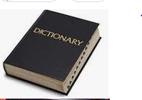

# INTRODUCTION

Dictionaries are a very useful data collection type. Dictionaries store key value pairs. Dictionaries are unordered and mutable.

## Dictionary Structure

Dictionaries are contained within braces {}. Dictionaries contain sets of key-value pairs. The keys are unique values that can be strings, integers or booleans. Values can be any data type: string, integer, boolean, list or even another dictionary. Sets of key value pairs are comma separated. Here is a sample dictionary:



Above we have fruit names as the keys and amounts as the values.

## Adding to a dictionary

To add key value pairs to a dictionary:

dictionary_name[‘new_key’]=new value

Here is a sample working with our Amnt_fruit dictionary:

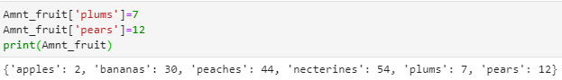

**Deleting from a dictionary**

To delete a key value pair from a dictionary:

del name_of_dict[“key”]

Here is a sample from our Amnt_fruit dictionary:

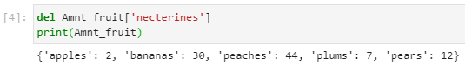

Above, we successfully deleted the key ‘necterines’ along with its value, 54.

**Accessing values in a dictionary**

To access a value in a dictionary call on the dictionary name, along with the key.

Dictionary_name[‘key’]

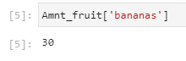

**Looping through a dictionary**

### Return the key

Looping through a dictionary will return the keys.

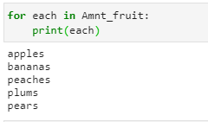

### Return the value

We can specify to return the value when looping through a dictionary.

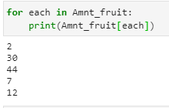

Alternatively, we can use the .values() method:

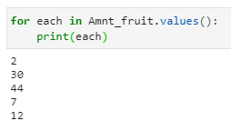

1. **Return the sets of key:value**

Using the .items() method in the loop, we can return key, value pairs from a dictionary:

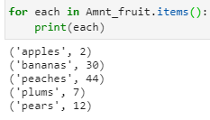

FREQUENCY TABLES

A frequency table is a dictionary used to store the frequency of unique values. It can be values from a list, a pandas series, or values of a dictionary.

dictionary=dic={'sara':'pink','tom':'yellow','bill':'purple','Jill':'pink','Jane':'pink','Harry':'yellow','Jack':'orange','Kim':'purple'}

list=['pink','yellow','purple','pink','yellow','purple','pink','orange']

From either this list or dictionary we want the following table, counting the frequency of each value:

| pink | 3 |
| --- | --- |
| yellow | 2 |
| purple | 2 |
| orange | 1 |

How can we make a frequency table as a dictionary that looks like this:

{'pink': 3, 'yellow': 2, 'purple': 2, 'orange': 1}

First initialize and empty dictionary:

freg_table={}

Then, loop through your list, series, or dictionary values:

for each in list:

for each in dic.values()

for each in data_frame[‘series’]

Create an if statement to check if the value has been put into your frequency table, if it is not yet in it, then you will want to set the value as the key, and 1 as the value in your frequency table.

if each not in freq_table:

freq_table[each]=1

The above code will add a key to your dictionary with the value of one, the first time that the key appeared.

Now you will create an else statement, meaning if the next item is already in your frequency table. You will want to then increment the value in your frequency table by 1.

Else:

freq_table[each]+=1

Here are 2 examples of coding:

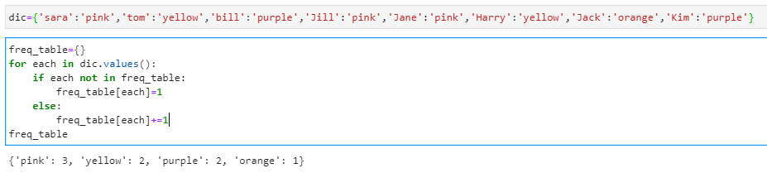

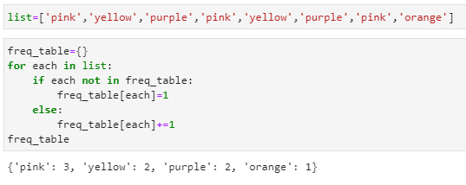

To learn more about dictionaries, see these links:

<https://docs.python.org/3/tutorial/datastructures.html>

<https://www.w3schools.com/python/python_dictionaries.asp>

https://realpython.com/python-dicts/